Title or Task: | Title Drawing in Word  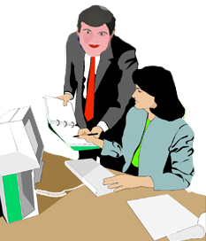

Description:

Files Required
Suitable for Classes: | All classes
Area: | Technology & Enterprise
Teacher: | Mr Peter Faulks

Timeline

Date Due:

Task Brief:

Outcomes:

Items highlighted in yellow are tasks for you to complete
Items in Blue italics are help tips

Worksheet Drawing in Word or Power Point

Drawing in Word or Power Point can be a more powerful aspect than you might
imagine, if you do noy have Corel, Adobe or a dedicataed drawing package then Word or Power Point is your answer, and you may be surprised at how powerful it can be… this student has given permission to use her face in all teaching sessions…

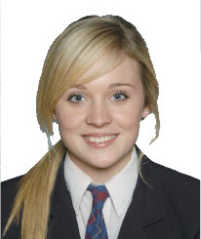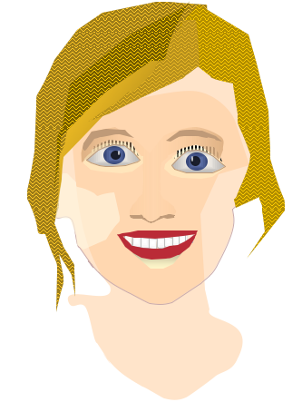

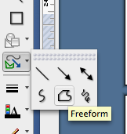
Lets say we wish to copy this into an Avatar Cartoon Face

First lets look at the FREEFORM TOOL

This tool used with EDIT POINTS is very usefull

WHEN WORKING USE 200% - 500% to help you work points and drawings

Using our picture and the freeform tool draw a rough circle over the face using as many click poins as possible, then select the circle and make it slightly transparent with a face colour fill - this is the colour I used. 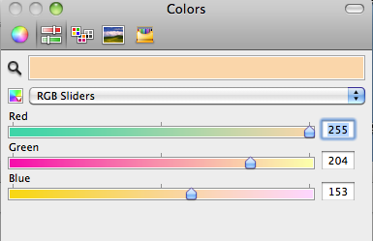

Using Edit Points

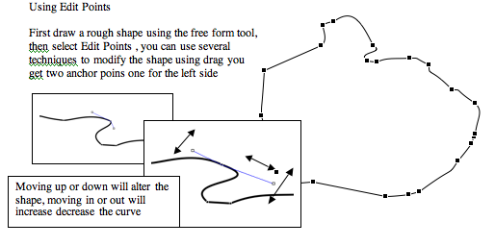

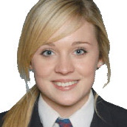

With Edit Points you can add anchor points or delete anchor points, open curves or close them and add smooth Points delete points or straighten a point
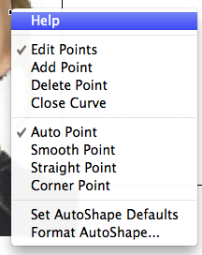
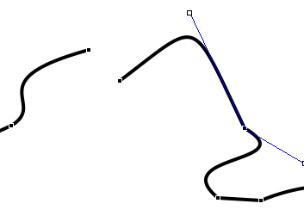
Opening a curve
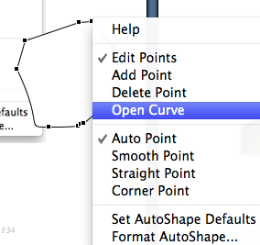
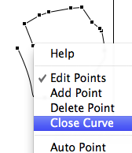
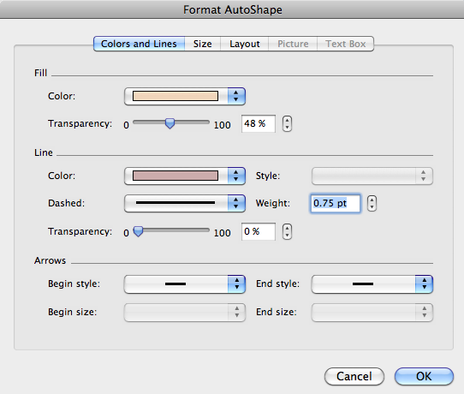

I used about 50% transparency select the rough circle - now click on EDIT POINTS

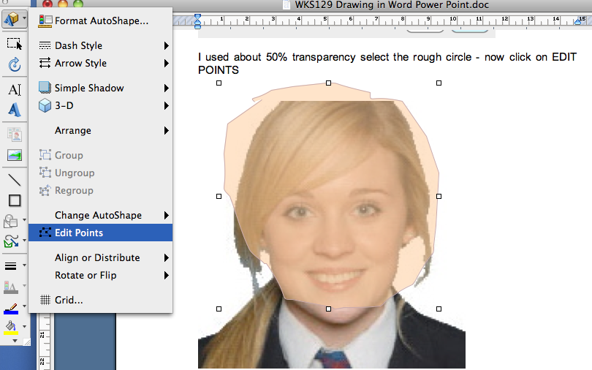

We can use these points like a PEN TOOL

Click on each point and move them in to fit the shape of the face, just above the hair line, we will work our way around the face. Use RIGHT MOUSE to bring up the contextual menu.

Drag one of the vertexes that outline the shape. A vertex is the point, indicated by a black dot, where a curve ends or the point where two line segments meet in a freeform shape.
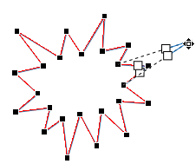
Working with editing points
- To add a point, click the shape outline while pressing Ctrl.
- To delete a point, click the point while pressing Ctrl.
- To have the point treated as a smooth point, press Shift while dragging either of the handles attached to the point. Once you stop dragging, the point will be changed to a smooth point. A smooth point joins two line segments of equal length.
- To have the point treated as a straight point, press Ctrl while dragging either of the handles attached to the point. Once you stop dragging the point will be changed to a straight point. A straight point joins two line segments of different lengths.
- To have the point treated as a corner point, press Alt while dragging either of the handles attached to the point. Once you stop dragging the point will be changed to a corner point. A corner point joins two line segments with one segment going off in a different direction.
- To cancel the change to the point and line segments, press Esc before releasing the mouse button.
- To open Edit Points mode with keyboard shortcuts, select the shape and then press Alt + JD, E, E.
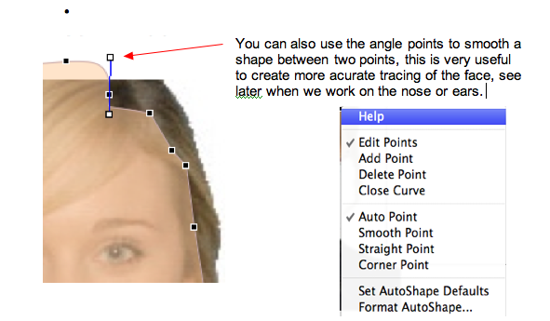

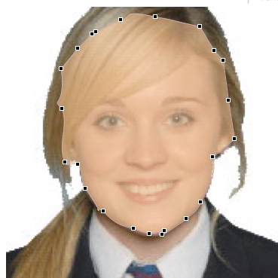

The Face
Now we can create the eyes, use the FREEFORM TOOL to draw a shape around the eye, you can use simple eyes but I prefere the effect eyes.
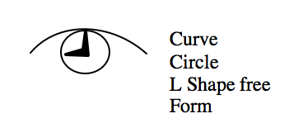

Use the freeform to draw the outside
of the eye
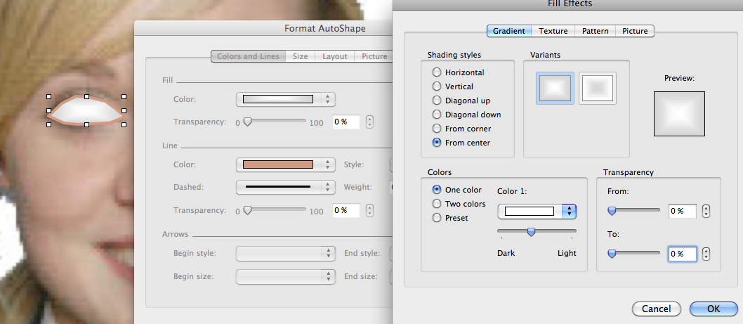
Use Edit Points to shape the eye

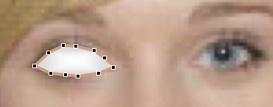

Select Line and pick a colour brown to add shape to eye with Gradient tool Circle and, add a circle for the Pupil and then add a circle for the eyeball using similar colour and gradient from center.
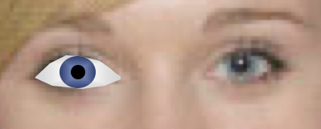
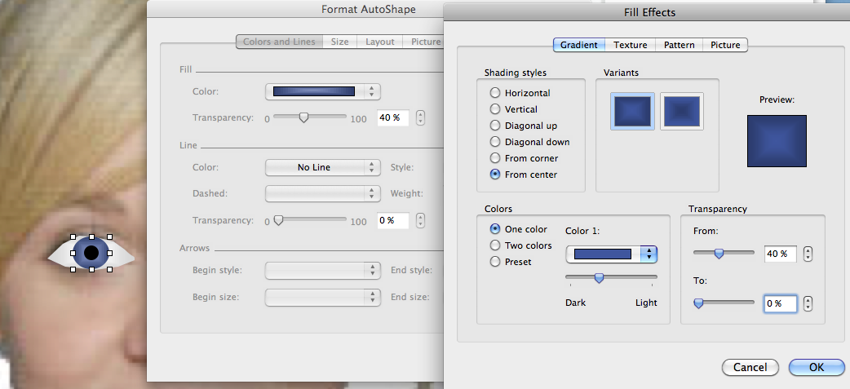

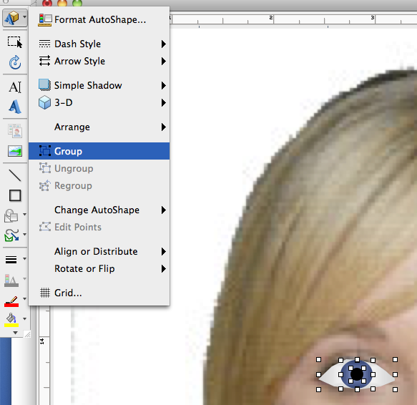
Add a highlight to the eye then group and copy the eye paste twice the second eye flip horizontal, use the picture and face and then place the eyes on top, They may need sizing down.

Match the eyes to size and place, now we work on the nose, using the FreeForm Tool draw a shape close to the nose but extend out to each eye as this will form the shape for eyebrows. Add a gradient then add the nostrils.

Now we can create the lips and teeth Top Lip using free form and edit points fill with red

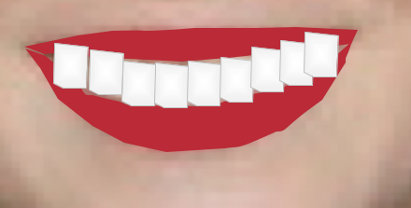

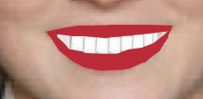

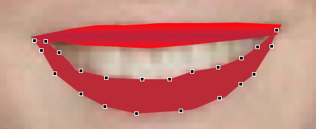

Teeth use free form fill with white with light grey outline bring lips over (to front of teeth)

Insert some eyebrows and shading for eyes

Next the hair which you should now be able to undertake yourself

Parts

Eyelashes

Now make your face, add some shading to the face and become creative.

For the hair use Paterns as your fill for the eyelashes use patters lines

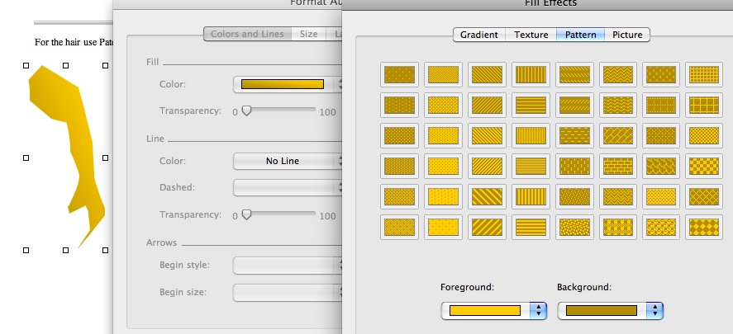

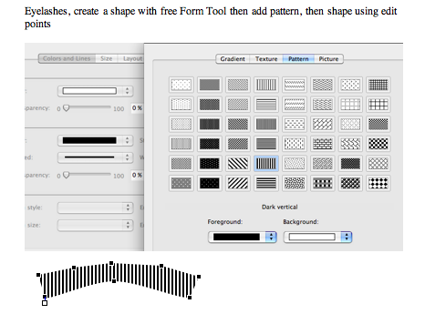
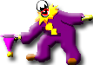
Need help just ask

